ENGLISH VERSION: https://s4s.my/en/home-english/
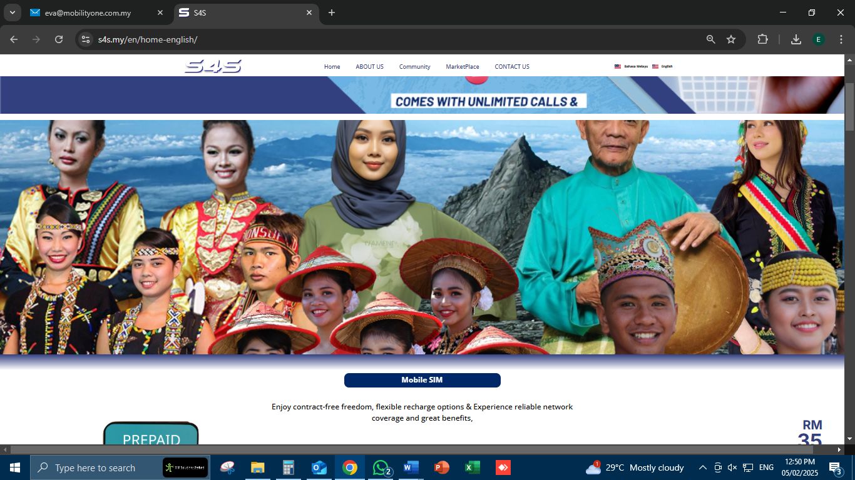
- Please change the picture (refer attachment A)
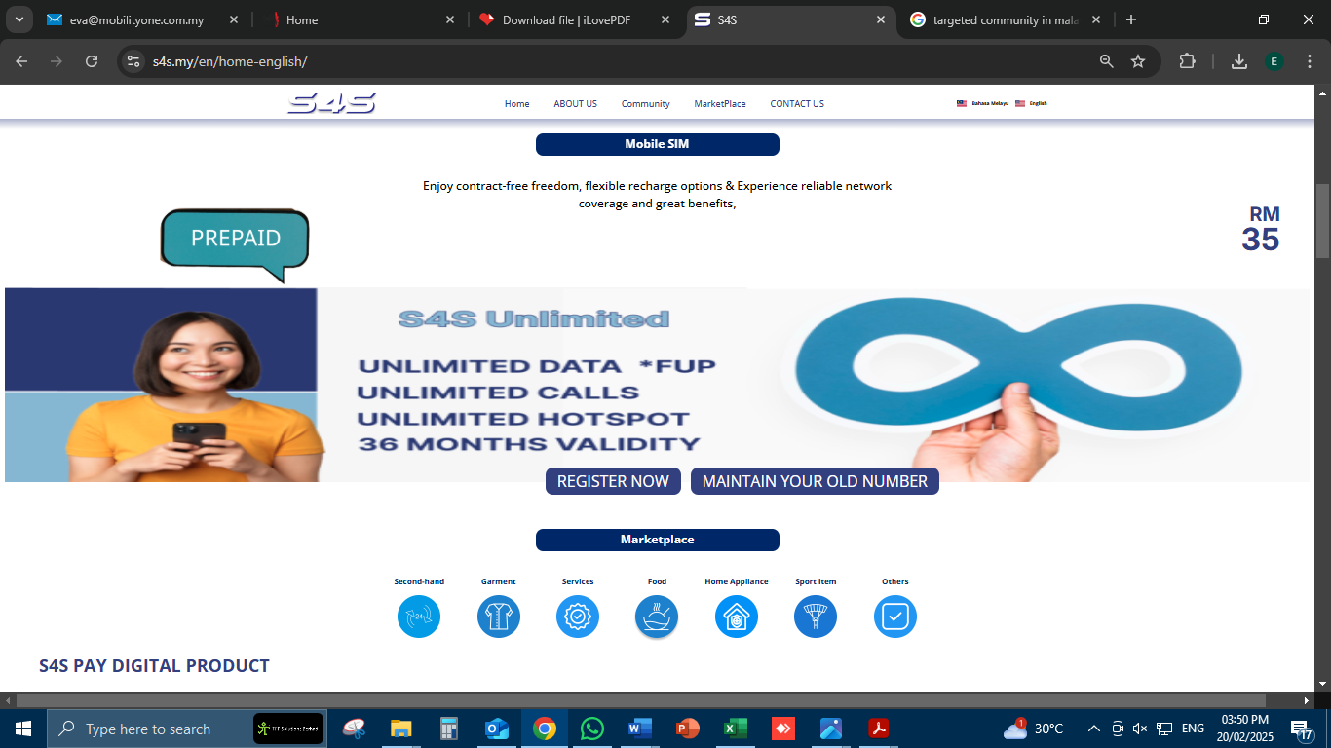
- Please change this picture (refer attachment No.1)

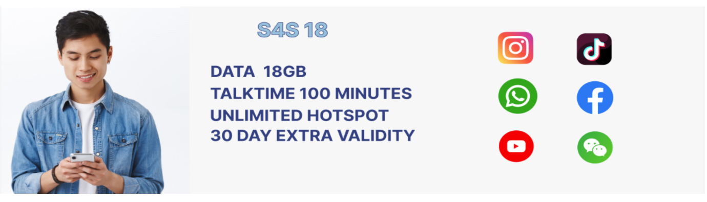
- Please change this picture (refer attachment No.2)
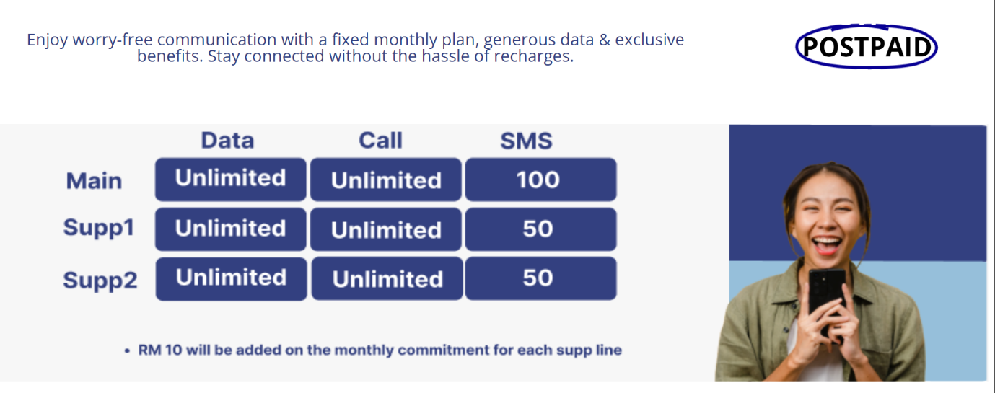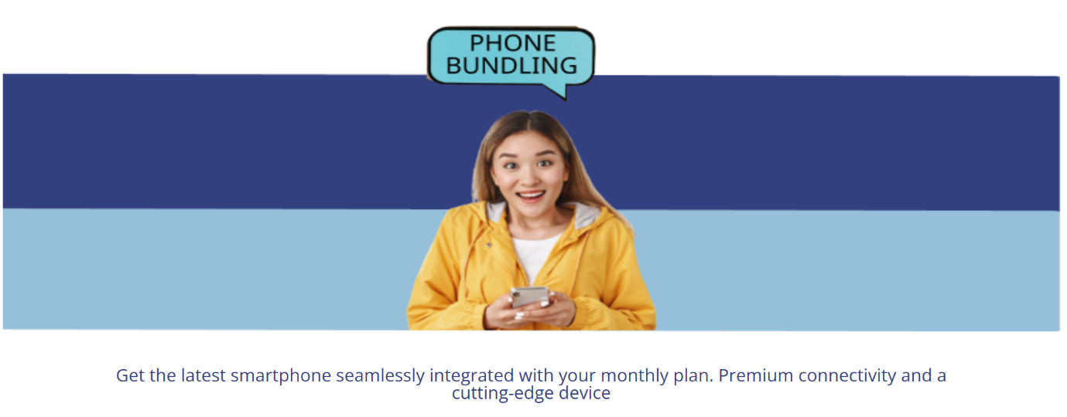
- As per check with Arif, currently we have not yet offered Postpaid & Phone Bundling, please delete this as it can be very misleading.

MALAY VERSION: https://s4s.my/

- Please change this picture (refer attachment No.3)
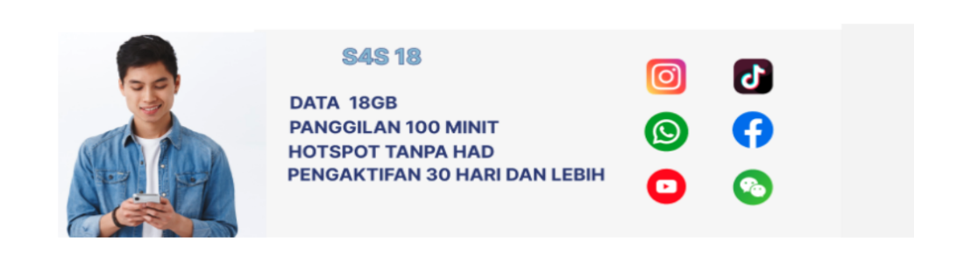
- Please change this picture (refer attachment No.2)
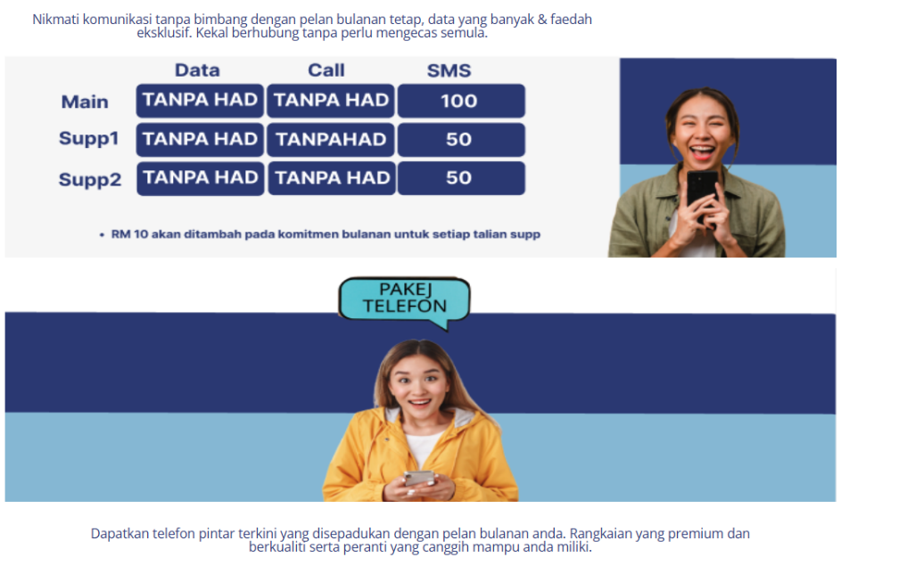
- As per check with Arif, currently we have not yet offered Postpaid & Phone Bundling, please delete this as it can be very misleading.

